Installing tomcat in RHEL 8 Ec2 Instance

1🡪sudo su

2🡪yum update

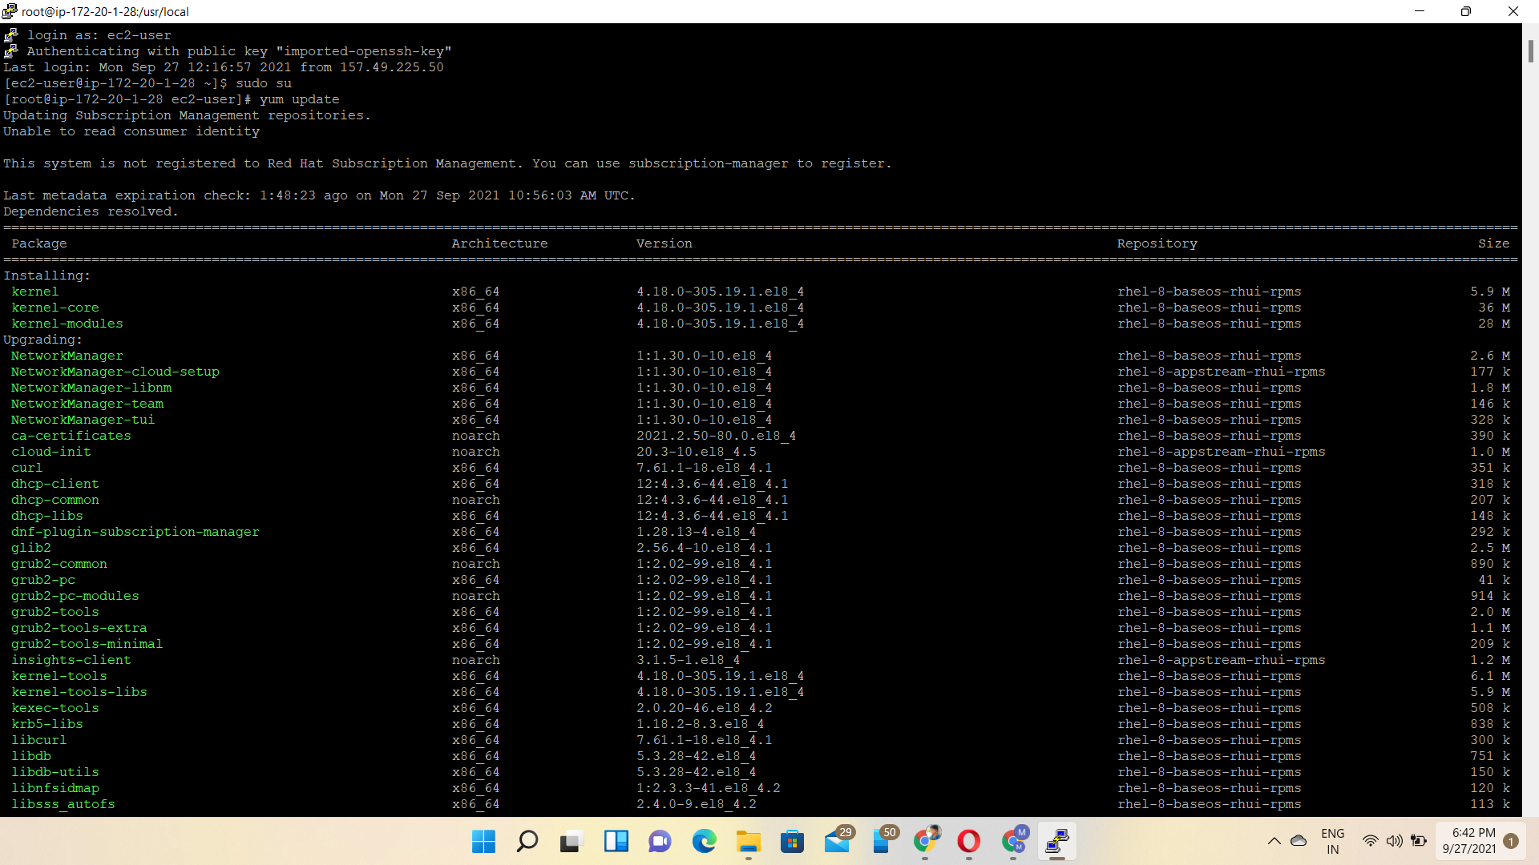

3🡪yum install java-1.8.0-openjdk-devel

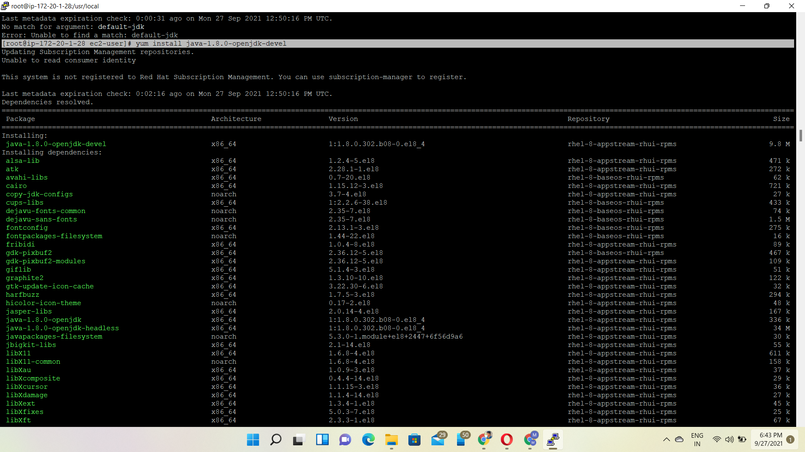

cd /usr/local

4🡪yum install wget –y

5🡪wget https://downloads.apache.org/tomcat/tomcat-9/v9.0.53/bin/apache-tomcat-9.0.53.tar.gz

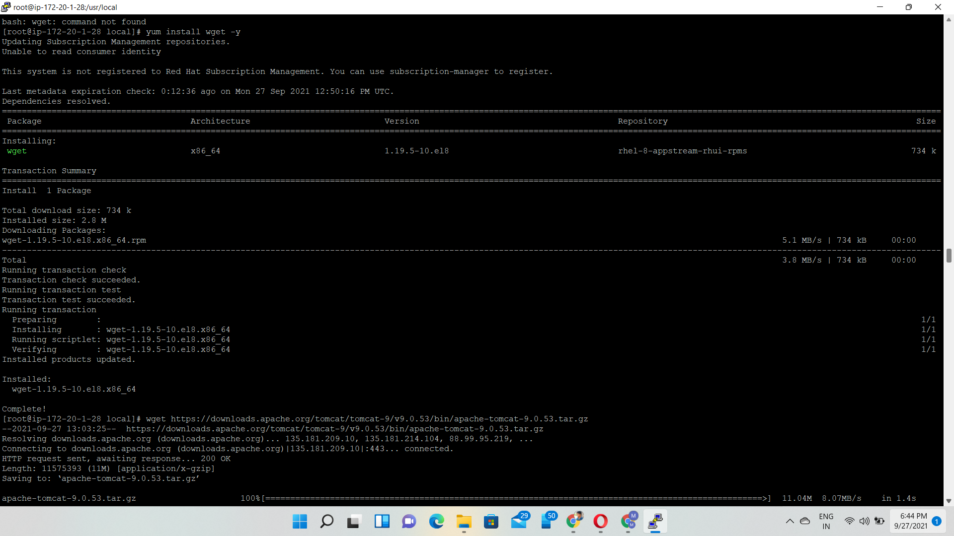

6🡪tar –xvf apache-tomcat-9.0.53.tar.gz

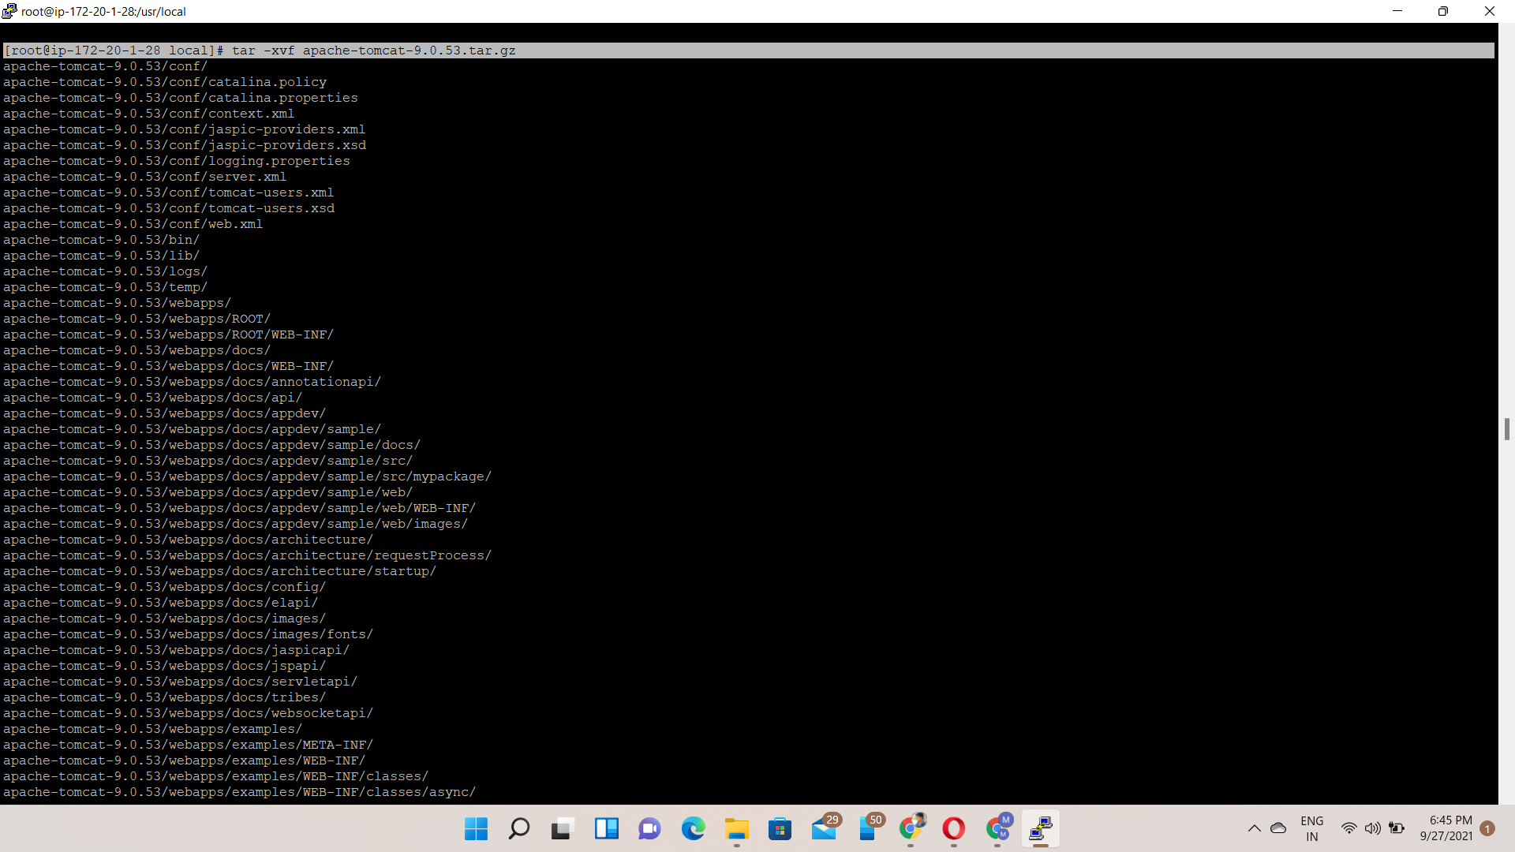

7🡪mv apache-tomcat-9.0.53 tomcat9

8🡪pwd tomcat9/

9🡪ls –l tomcat9/

10🡪useradd –r tomcat

11🡪chown –R tomcat:tomcat /usr/local/tomcat9

12🡪ls –l /usr/local/tomcat9

13🡪vi /etc/system/system/tomcat.service

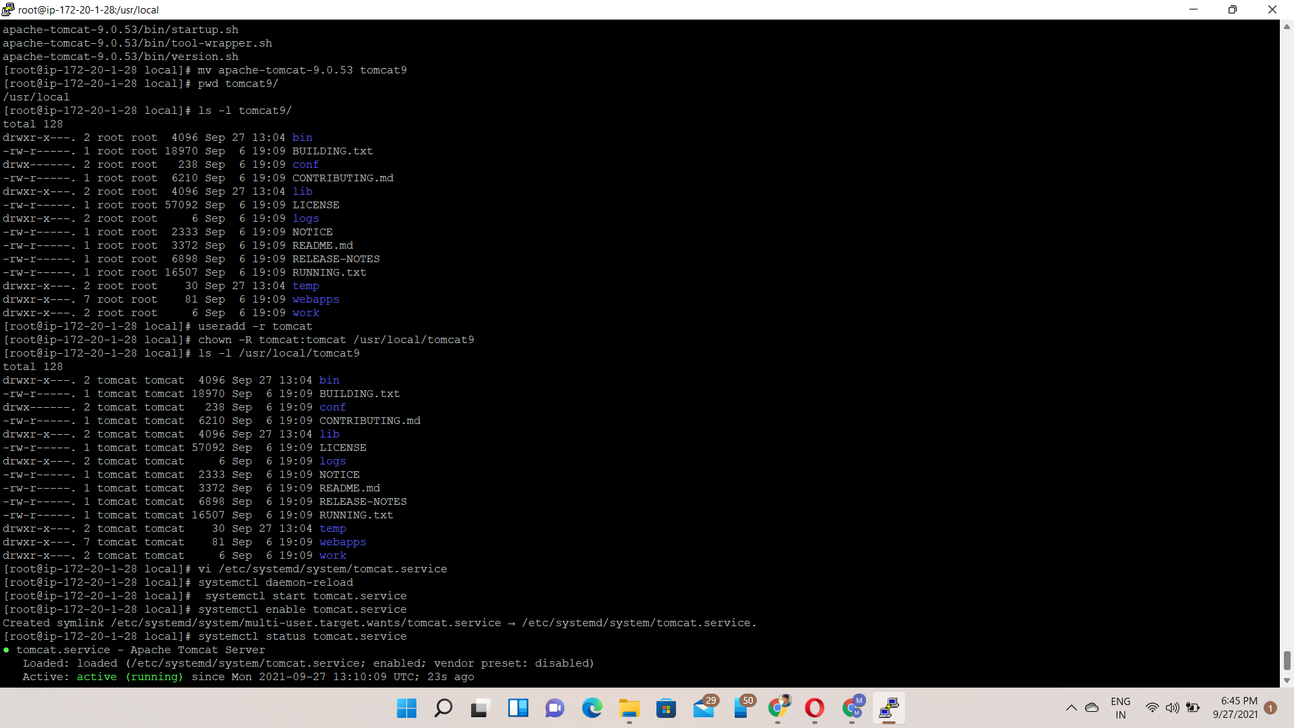

Vi Edit file🡪Copy & Paste the following configuration

[Unit]

Description=Apache Tomcat Server

After=syslog.target network.target

[Service]

Type=forking

User=tomcat

Group=tomcat

Environment=CATALINA_PID=/usr/local/tomcat9/temp/tomcat.pid

Environment=CATALINA_HOME=/usr/local/tomcat9

Environment=CATALINA_BASE=/usr/local/tomcat9

ExecStart=/usr/local/tomcat9/bin/catalina.sh start

ExecStop=/usr/local/tomcat9/bin/catalina.sh stop

RestartSec=10

Restart=always

[Install]

WantedBy=multi-user.target

14🡪systemctl daemon-reload

15🡪systemctl start tomcat.service

16🡪systemctl enable tomcat.service

17🡪systemctl status tomcat.service

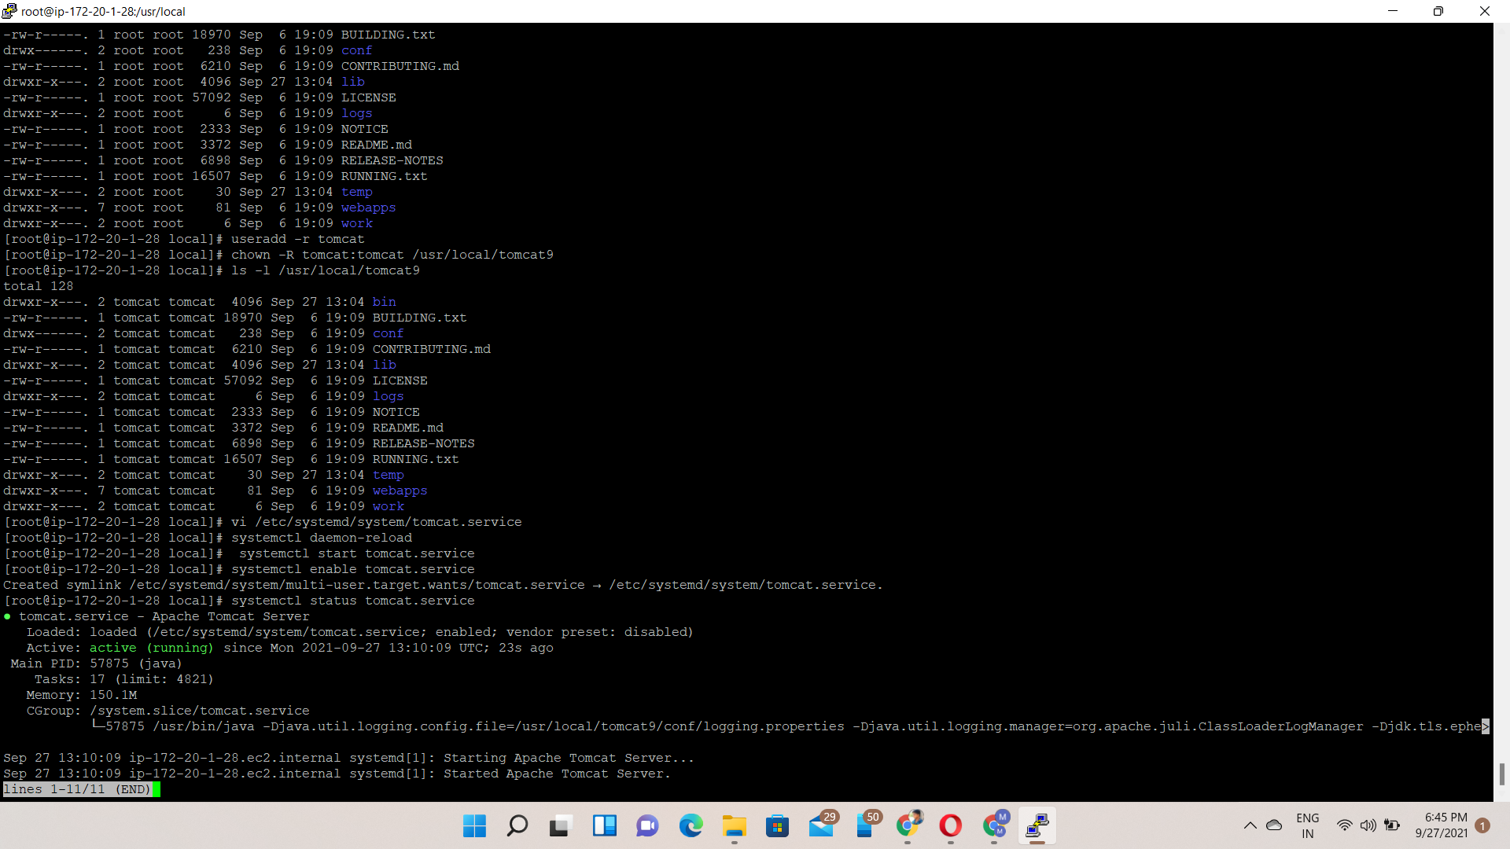

Browse the public ip:8080 port

